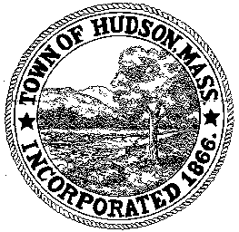

CONSERVATION COMMISSION
78 Main Street, Hudson, MA 01749
(978) 568-2020

Paul Byrne, Chairman W. Minot Wood, Vice Chairman David Esteves, Member

Terrence Joyce, Member Leif Longtine, Member Joseph Rodrigues, Member Al Tashian, Member

Agenda
July 16, 2009 7:00 P.M.

- Preliminaries
  - Open Meeting
  - Roll Call
1.3 Additions or Deletions to the agenda

2.0 Hearings and Appointments
2.1 DEP 190-542
Applicant: Rebecca Mattison
Location: 277 Chestnut Street
Project Description: The construction of an addition and deck at the rear of the house.

3.0 General Business
3.1 DEP 190-477
Erica Bigelow et al: request for Extension
WPA 310 CMR 10.00
10.05 (8) “The issuing authority may extend an Order for one or more periods of up to three years each, which shall be made on Form 7. The request for an extension shall be made to the issuing authority at least 30 days prior to expiration of the Order”.

3.2 Voucher 063109 $1816.60
3.3 Voucher 071609 $657.00
3.4 Voucher 071509 $1,438.00

4.0 Correspondence/Discussion
4.1 Supplemental Environmental Impact Report – Highland Commons
4.2 Review and Comments 481 Main Street
4.3 Review of DPW work under DEP 190-520
Mason Street, Murphy Road, Cox/Forest/Woodrow
4.4 Santa Barbara Pub
4.5 Planting schedule
4.6 CPA Application

5.0 Adjournment

